**Experiment: - 10**

**Student Name: SUMIT KUMAR UID: 20BCS8226**

**Branch: BE-CSE Section/Group: MM 808 A**

**Semester: 5th Date of Submission: 12-11-2022**

**Subject Name: Competitive coding - I Subject Code: 20CSP-314**

1. **Marc’s Cakewalk Program Code:**

#include <bits/stdc++.h> using namespace std;

#define rep(i,n) for(int (i)=0;(i)<(int)(n);++(i))

#define rer(i,l,u) for(int (i)=(int)(l);(i)<=(int)(u);++(i))

#define reu(i,l,u) for(int (i)=(int)(l);(i)<(int)(u);++(i)) static const int INF = 0x3f3f3f3f; static const

long long INFL = 0x3f3f3f3f3f3f3f3fLL; typedef vector<int> vi; typedef pair<int, int> pii; typedef vector<pair<int, int> > vpii;

typedef long long ll;

template<typename T, typename U> static void amin(T &x, U y) { if (y < x) x

= y; } template<typename T, typename U> static void amax(T &x, U y) { if (x < y) x

= y; }

int main(void) { int n; while (~scanf("%d", &n)) {

vector<int> c(n); for (int i = 0; i < n; ++ i)

scanf("%d", &c[i]);

sort(c.begin(), c.end());

ll ans = 0; rep(i, n) ans += (ll)c[i] << (n - 1 - i); printf("%lld\n", ans);

}

}

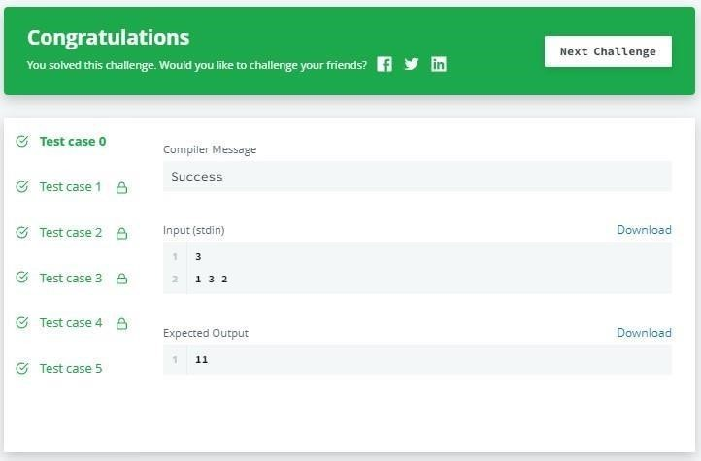

# Output:

1. **Grid Challenge**

**Program Code:**

#include <bits/stdc++.h> using namespace std;

ypedef long long ll;

typedef pair<int, int> Pii; typedef pair<ll, ll> Pll;

#define _USE_MATH_DEFINES #define _CRT_SECURE_NO_DEPRECATE

#define FOR(i,n) for(int i = 0; i < (n); i++) #define sz(c) ((int)(c).size()) #define ten(x) ((int)1e##x) #define tenll(x) ((ll)1e##x)

template<class T> T gcd(T a, T b) { return b ? gcd(b, a % b) : a; } void solve(){ int n; cin >> n; vector<string> v(n);

FOR(i, n) cin >> v[i];

FOR(i, n) sort(v[i].begin(), v[i].end()); bool b = true;

FOR(i, n){ string x;

FOR(j, n) x.push_back(v[j][i]); string y = x; sort(y.begin(),

y.end()); if (x != y) { b

= false;

}

} puts(b ? "YES" :

"NO"); }

int main(void){ int t; cin >> t; while

(t--) {

solve(); }

}

# Output:

5EM¥TNEXT0F

NAAC

GRADEMW€•



Test case 0

Compiler Message

Test case 1

Success

Test case 2

Download

Test case 3

Test case 4

Test case 5

Test case 6